AJAX Concept

* What is Scripts: Interaction of the client-side XMLHttpRequest object with server-based scripts
  + XMLHttpRequest object is both instantiated and handled a tad differently across the browser gamut
    - Internet Explorer: Active XControl
    - Firefox, and Safari: Basic Javascript Object
* Steps
  + create an object of the XMLHttpRequest type
  + validate that it has been created successfully
  + point where it will go and where the result will be displayed
  + then send it

HTTP Request and Response Fundamentals

* HTTP: host header request is sent to server
  + 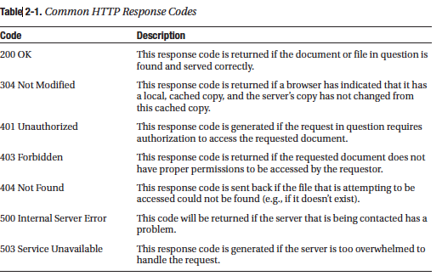
* 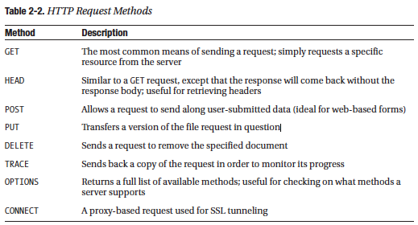

The XMLHttpRequest Object

* XMLHttpRequest Methods
  + 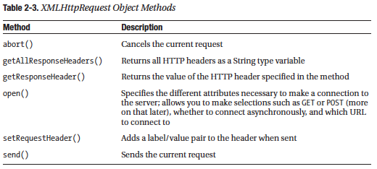
  + Abort: used if you are concerned with the length of connection
  + getAllResponseHeaders(): to get header information
    - 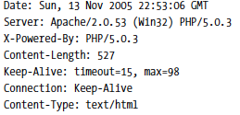
  + getResponseHeader("headername")
    - Another Example: getResponseHeader ("Content-Length")
    - to obtain the content of a particular piece of the header
    - Example Usage: to retrieve the size of the document requested
  + open ("method","URL","async","username","pswd")
    - method you use to open a connection to a particular file on the server.
    - It is where you pass in the method to open a file (GET or POST)
    - Not all the arguments are required
  + setRequestHeader("label","value")
    - you can give a header a label of sorts by passing in a string
    - this method may only be invoked after the open() method has been used, and must be used before the send function is called
  + send("content")
    - helpful for processing forms, as it allows you to pass the values of form elements

XMLHttpRequest Properties

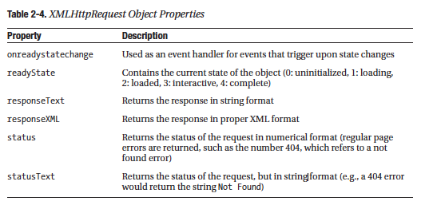

* onreadystatechange - For example, if you have a function that handles some form of initialization, you could get the main set of functionality you want to fire as soon as the state changes to the complete state
* readyState - For example, you could have a set of code execute when readyState is loading, or stop executing when readyState is complete
* responseText - If you are
* firing a request to a script of some sort, the output of the script will be returned through this property. With that in mind, most scripts will make use of this property by dumping it into an innerHTML property of an element
* responseXML - similarly to responseText, but is ideal if you know for a fact that the response will be returned in XML format
* status - This property dictates the response code (a list of common response codes is shown in Table 2-1)
* statusText - This property is merely a textual representation of the status property. Where the status property might be set to 404, the statusText would return Not Found

DOM: Lynda

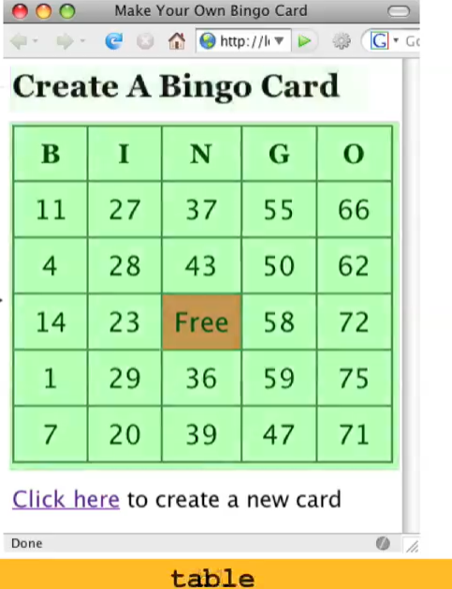

DOM:

* The Green Area is an Object
* The Title is an Object
* The Page itself is an Object called DOM

Property

* Whatever is inside the DOM is a property of the particular DOM

Can Be Identified Using Firefox Firebug and Google Inspector

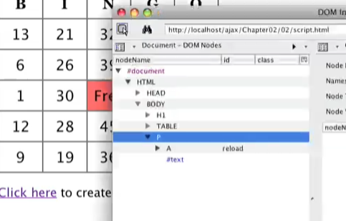

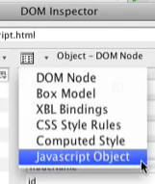

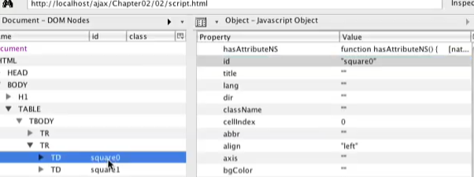

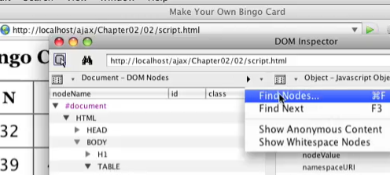

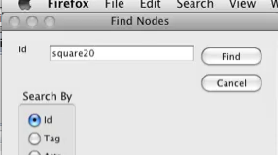

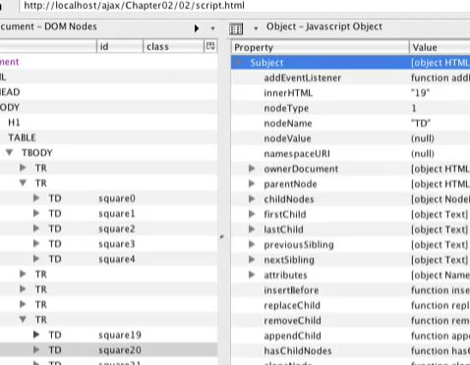

Example

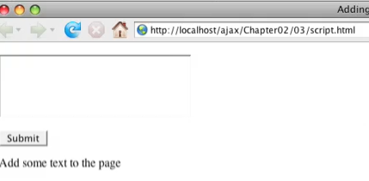

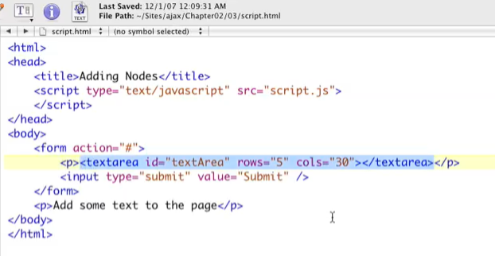

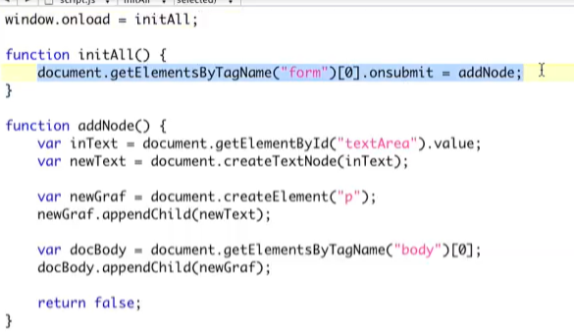

Window.onload – Call all the function when the window opens

See the HTML and it will make sense

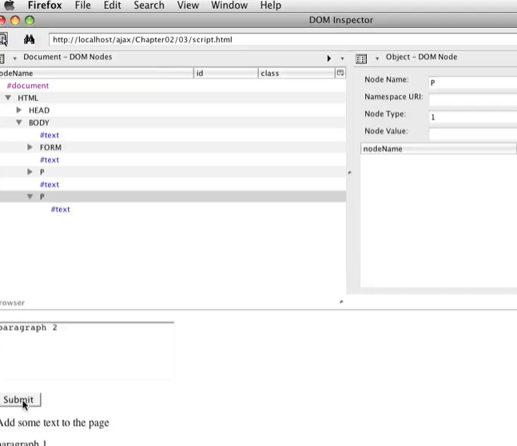

XML

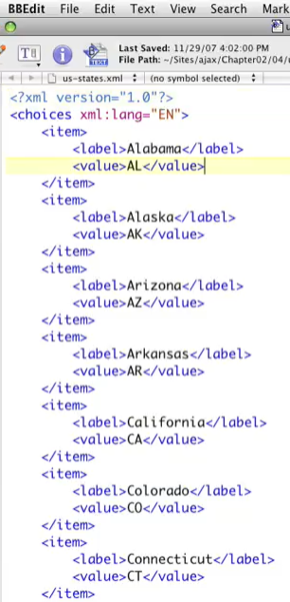

View in Firefox

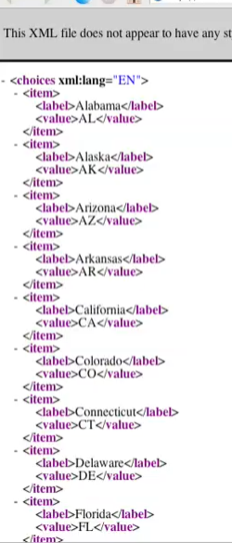

You can fold things up

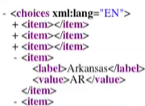

In DOM View

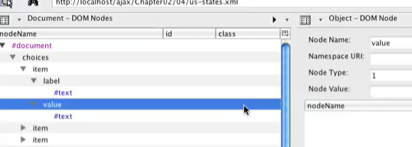

Can be controlled by DOMs Tags and ID to retrieved information out of it

XML HTTP Request or XMLHttpRequest

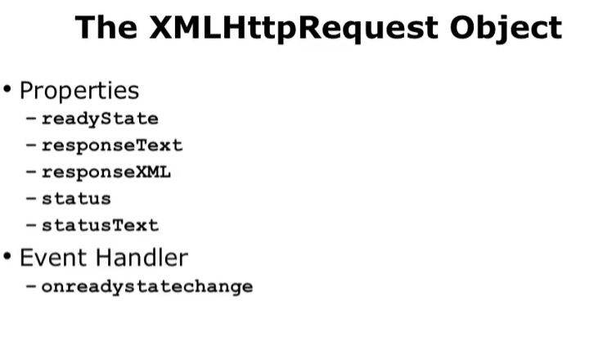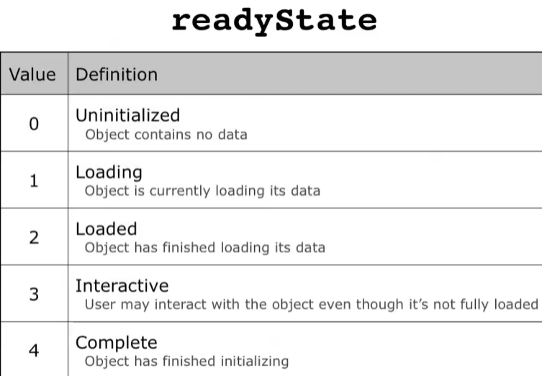

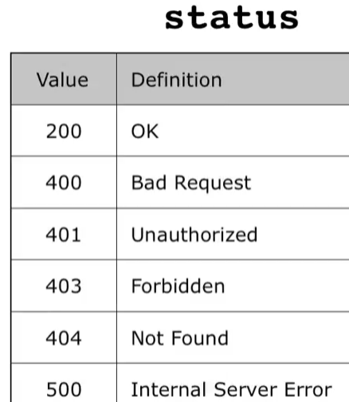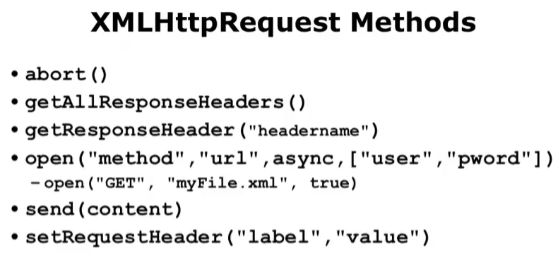

XHRstates.mov

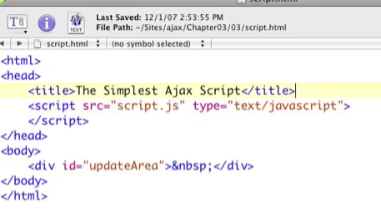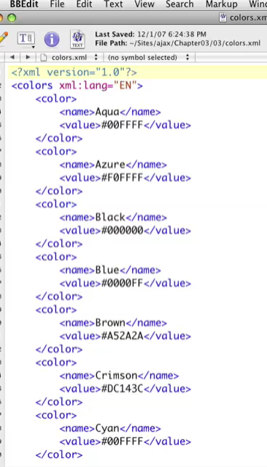

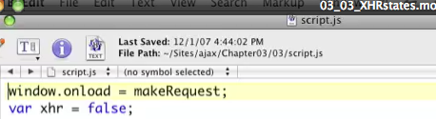

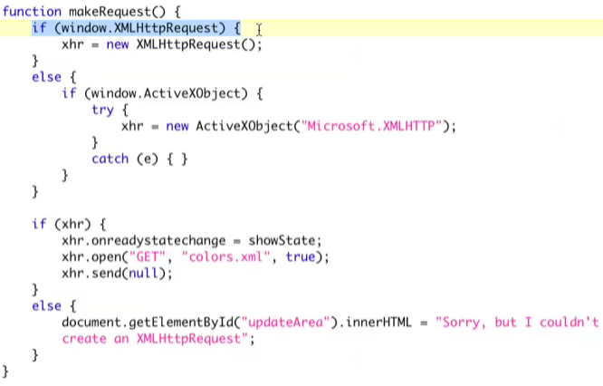

window = browser

checking to see if the browser understands XMLHttpRequest()

ActiveXObject if for IE 6

Try if not catch e() – and XHR will not be set

If xhr show ready state this will relate to function showstate

If xhr fails refresh the update area and show the sorry message

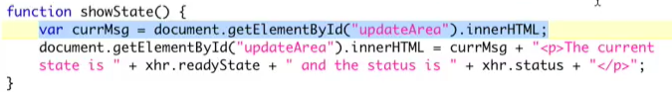

Output:

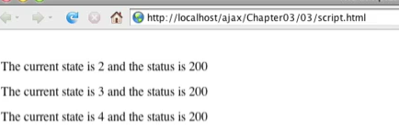

XHRContent Example

* Same Script.js is the same as Previous Example
* Same colors.xml is the same as Previous Example

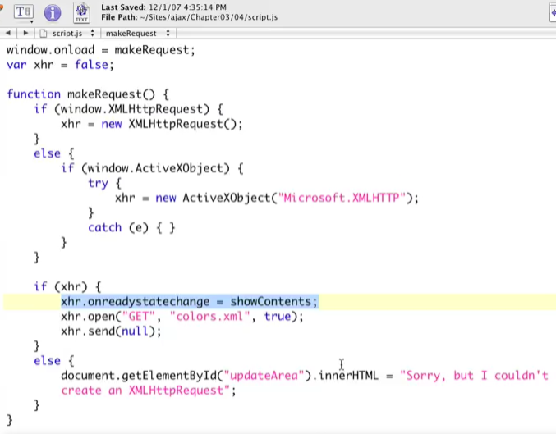

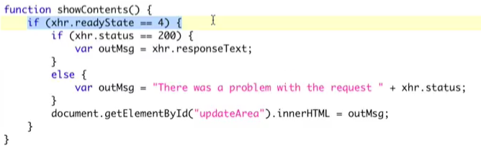It only executes when the ready state is 4

Output:

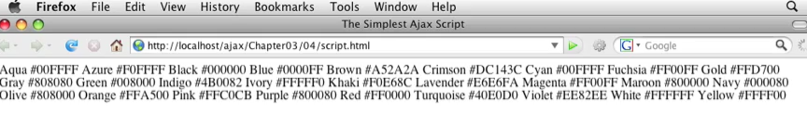

XHROutput

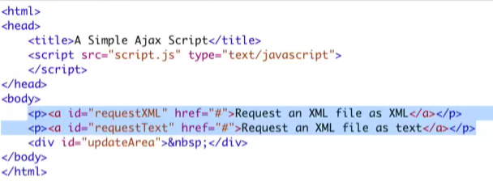

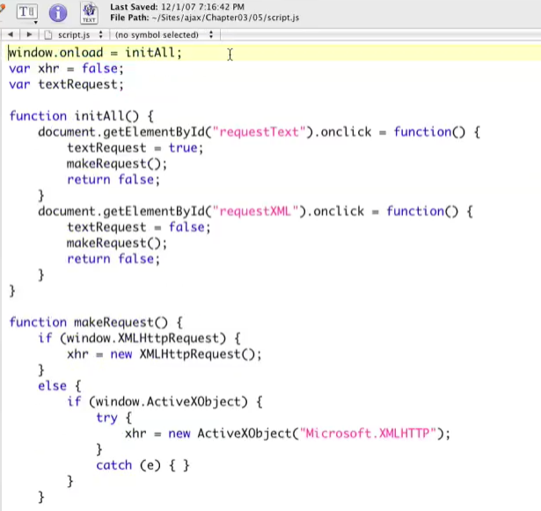

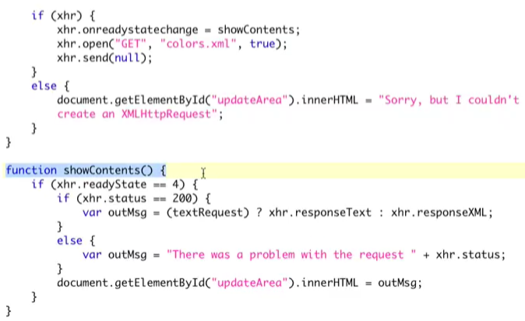

Colors.xml didn’t change from previous

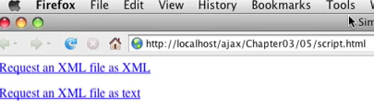

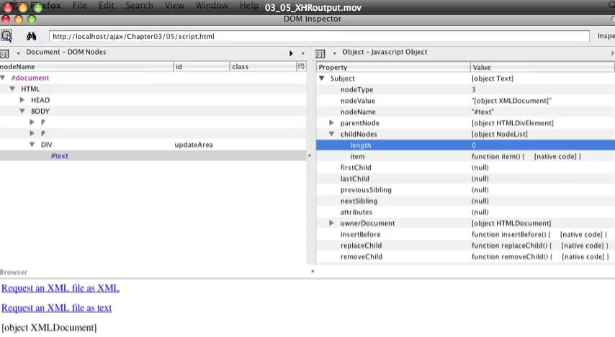

This is an out of when clicking an XML file as XML

Request an XML as text

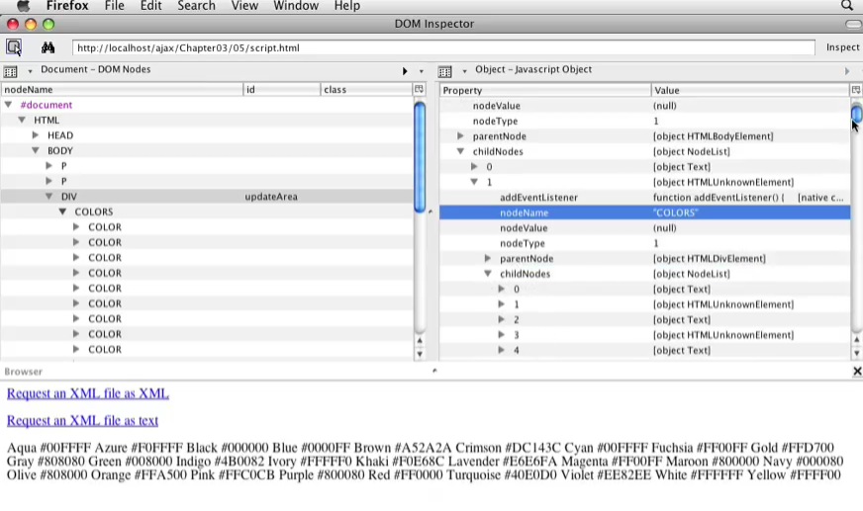

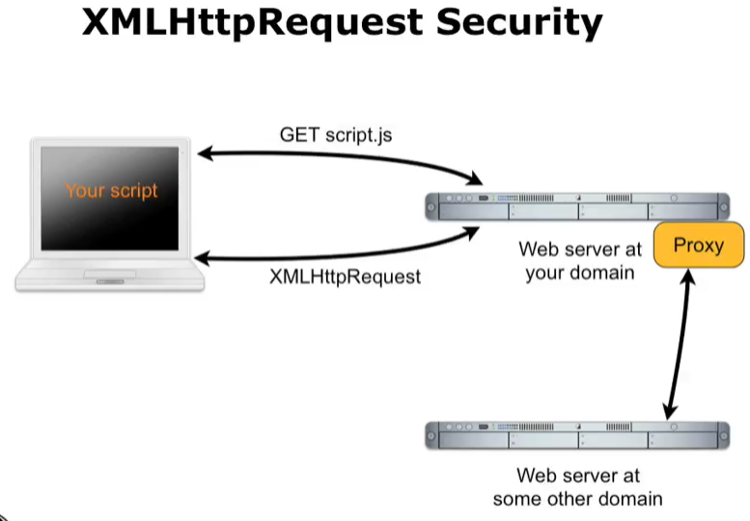

ModifyingHTML mov2

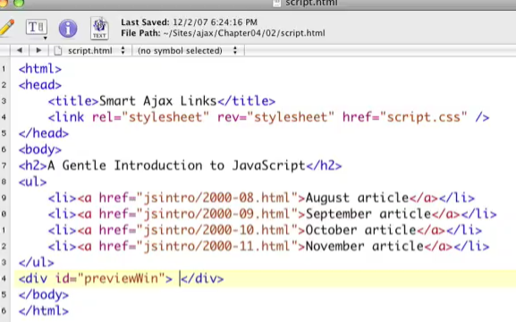

Add the HTML and CSS PreviewWin

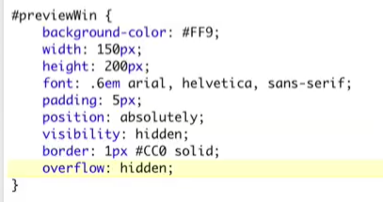



Add the Scritps on the Head

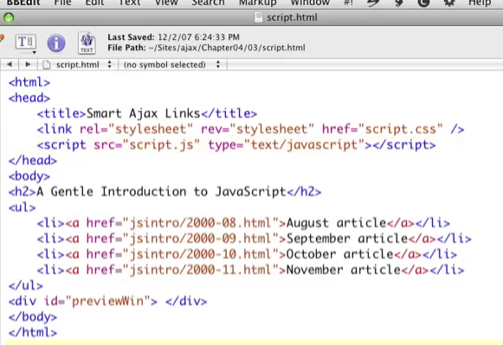

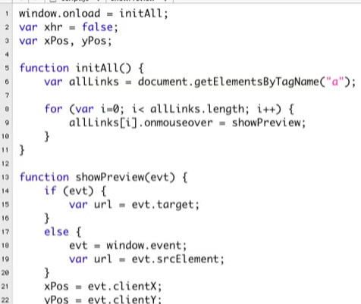

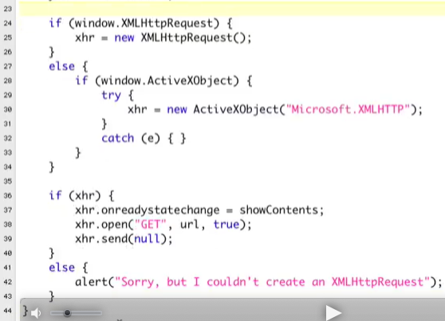

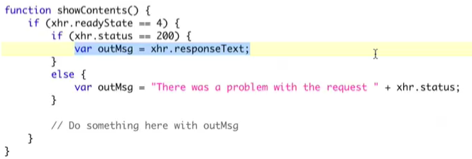

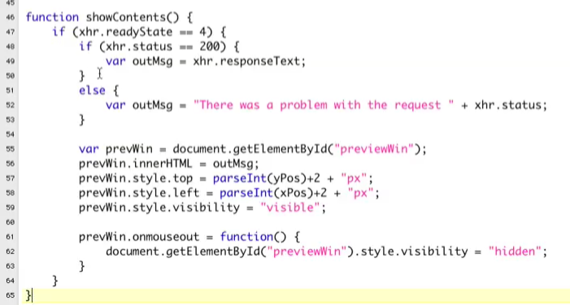

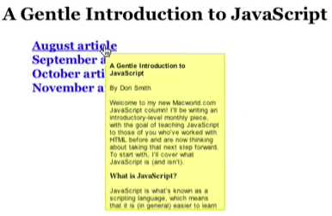

Reusing The Code

* Scripts.js is the same as previous exercise
* CSS:
* 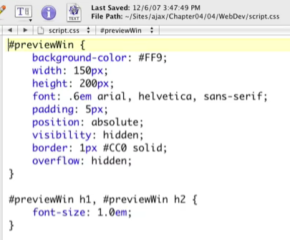
* index.html
* 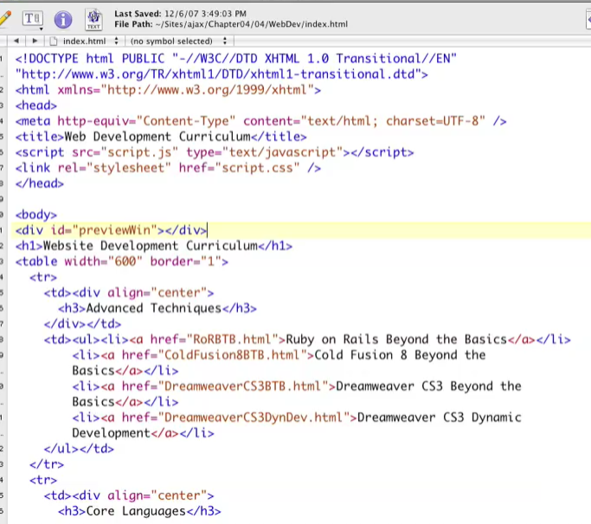
* 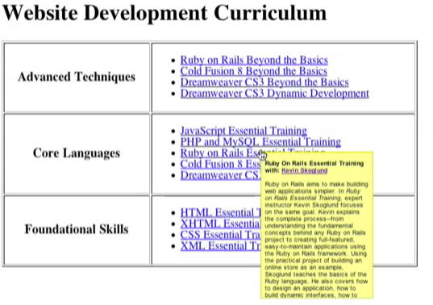
* It’s the same as the previous exercise
* All the changes made is attaching the Javascript file and the div tag (Note: Div tag can also be placed inside the Javascript)

New Example:

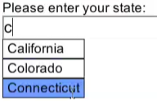 

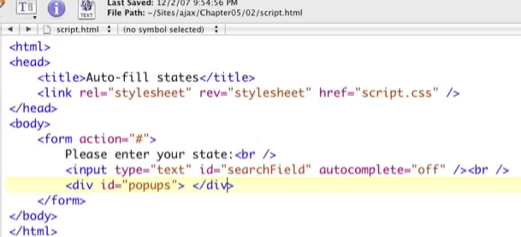

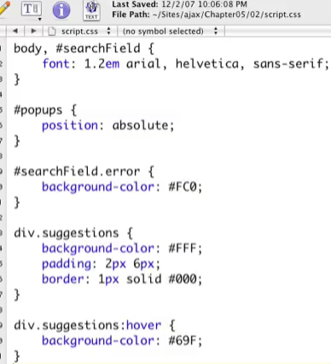

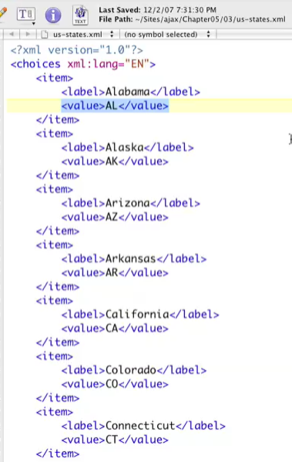

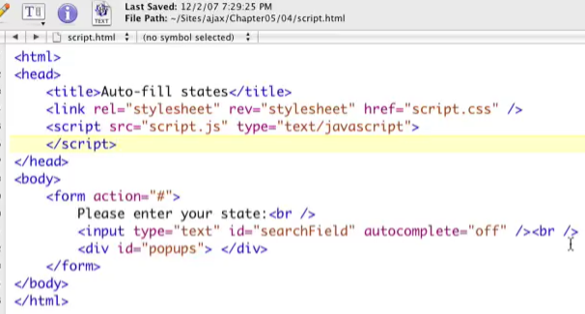

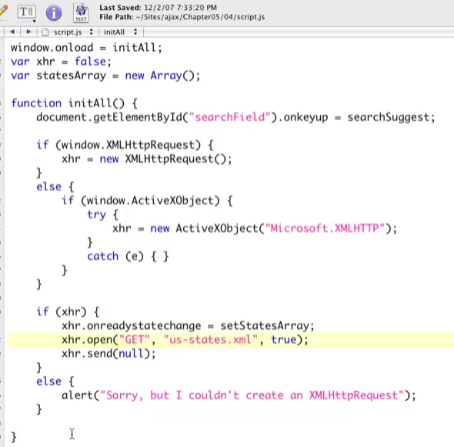

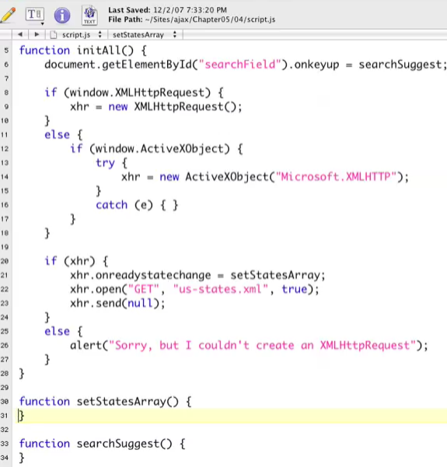

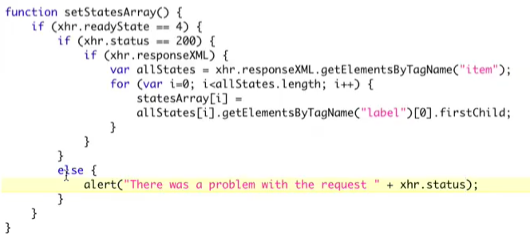

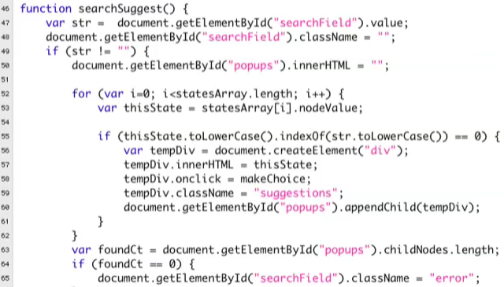

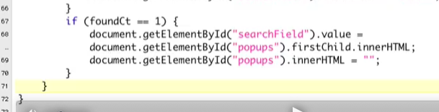

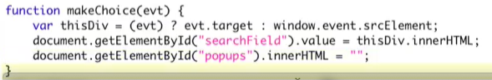

Reusing The Code:

